The Oporto Areas

To help you plan your trip in the city, we leave some information about the most famous areas of Porto.

Sé do Porto
This is the oldest neighbourhood in Porto, where the city of Porto was born. The cathedral of Porto is at the highest point of this area, where you can enjoy one of the best views of the city. It is also a great area to listen to the Fado.
Here are some recommendations to listen fado:

-Casa Mariquinhas (Rua de S. Sebastião, 25)
-Casa Porto à noite (Rua dos Mercadores, 170)
-Fado na Baixa (Rua de S. João Novo, 99)

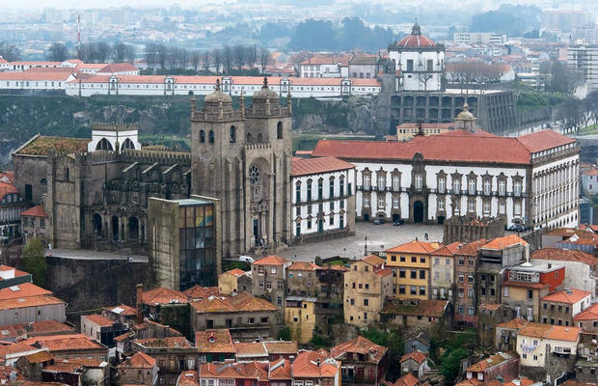

A Ribeira
Descending from the Sé district to the river, we find the Ribeira area.
It is one of the city's trademark images. It is here that are the famous colourful houses in front of the river, along with a walk full of the terraces and restaurants by the river. More than anywhere, it is here that one can feel the true spirit of Porto, with its people so typical and hospitable.

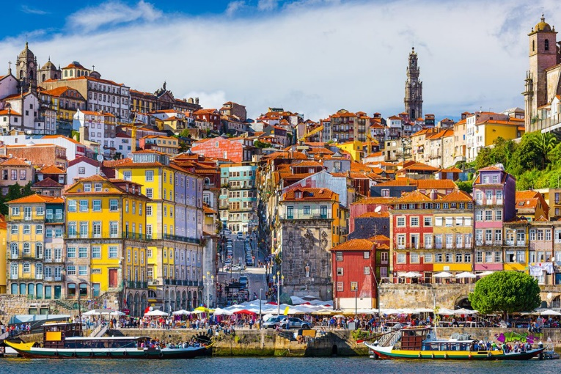

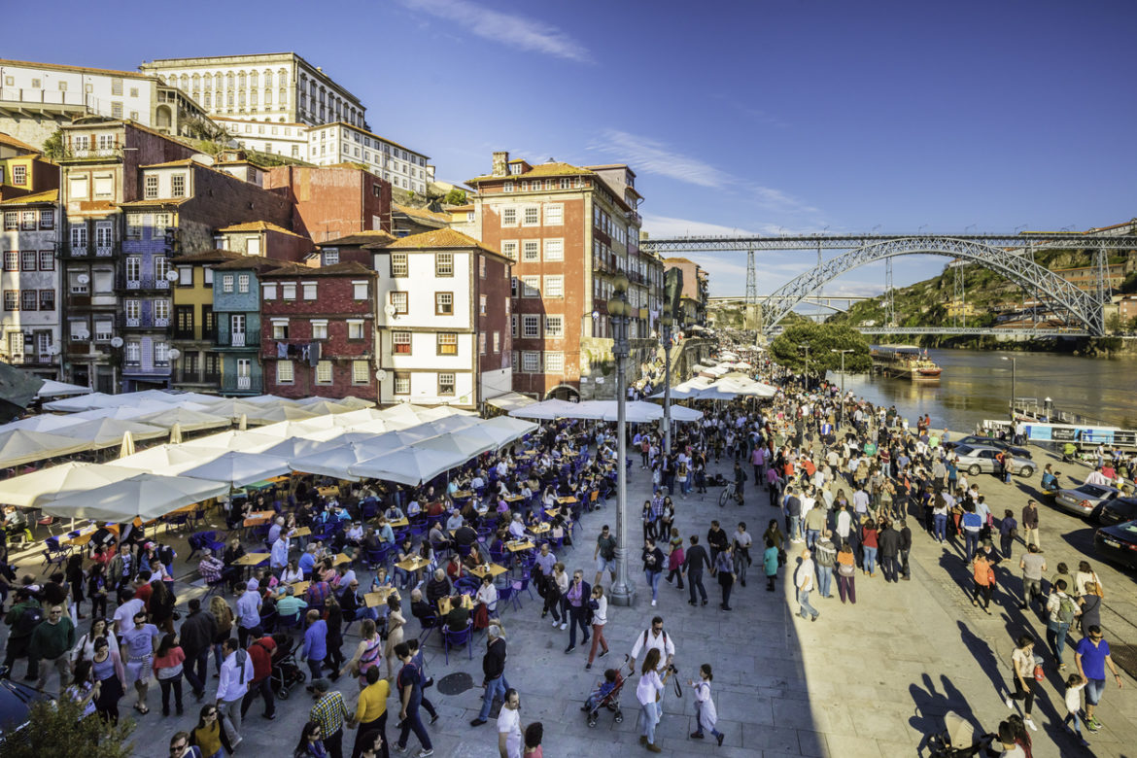

Miragaia
Along the Ribeira, heading towards the sea, you can enjoy a beautiful walk along the river, and you can also stop at some places of interest such as the World of Discoveries theme park museum, the Port Wine Museum and Oporto Customs House (the best congress center in Europe) where events and exhibitions are held constantly.
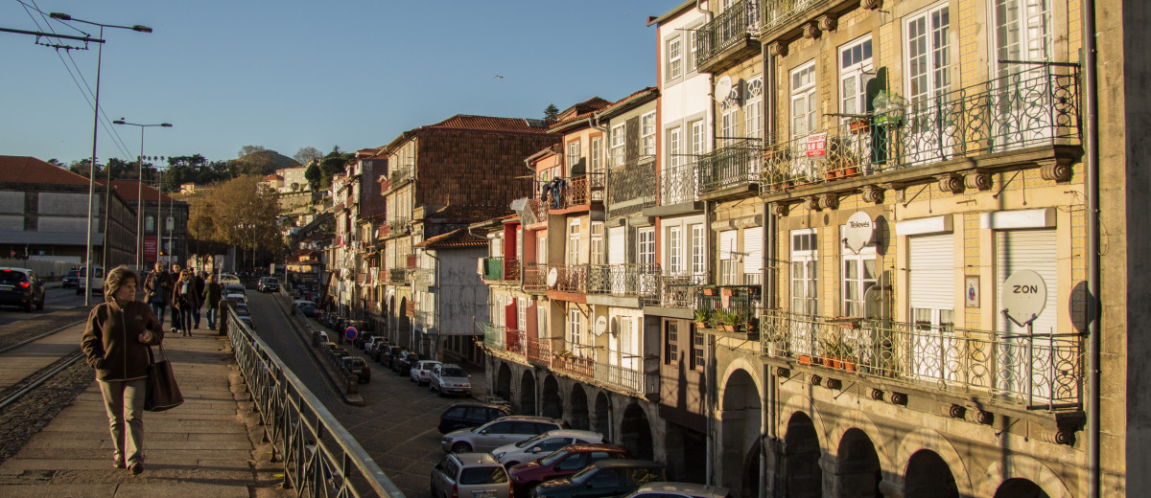
Going up a little, you will also be near the Crystal Palace.

Baixa do Porto
This is the most central part of the city. The Portuguese call it "Baixa" and it is the area constituted by the streets that surround the Aliados Avenue and the Liberdade Square.
This venue is often used for holding outdoor concerts or celebrating important moments in the city.
At the top of this avenue is located the municipal town hall of the city and the central avenue with the name of Avenida dos Aliados.
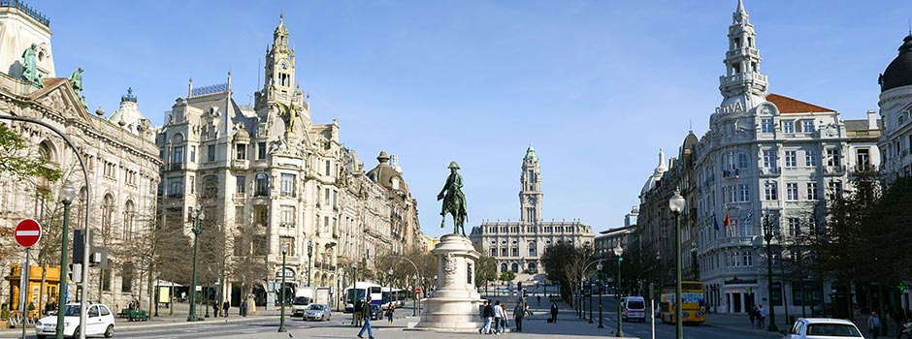

Cordoaria
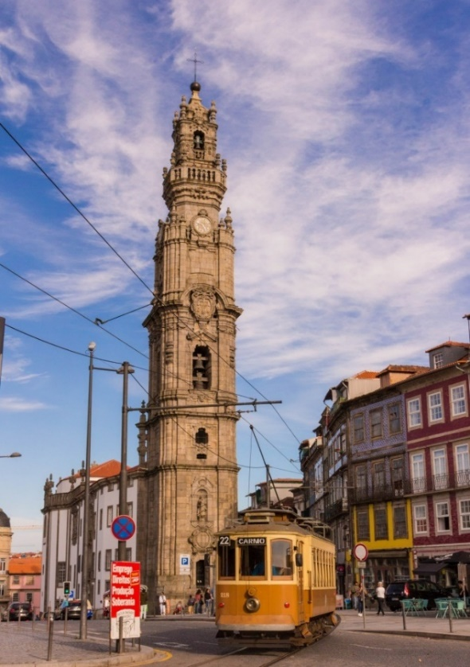
The zone of “Cordoaria”, preceded by the old garden of Mártires da Pátria, has this peculiar name due to the fact that it was the place where the “cordoeiros” (the men who made the ropes) made and sold the ropes. It dates from 1924 and since then you may find trees classified as of public interest and otherwise. For many, this garden is also an art space, since along it can find several sculptures, some of them exposed when the city of Porto was considered European Capital of Culture in 2001.
The Liberdade square, S. Bento station and the gardens of the Crystal Palace are all just a few minutes away on foot. Cordoaria is between the area of ​​Cedofeita and Miragaia.
This is where the famous Clerigos Tower is located.

Foz do Douro
At the junction between Rio and the Ocean, we find the area of ​​Foz do Douro. A more recent area of ​​the city where the beaches are the highlight of this area of ​​the city.
It is the most expensive residential area of ​​the city, where the views over the river and the sea are a real privilege.
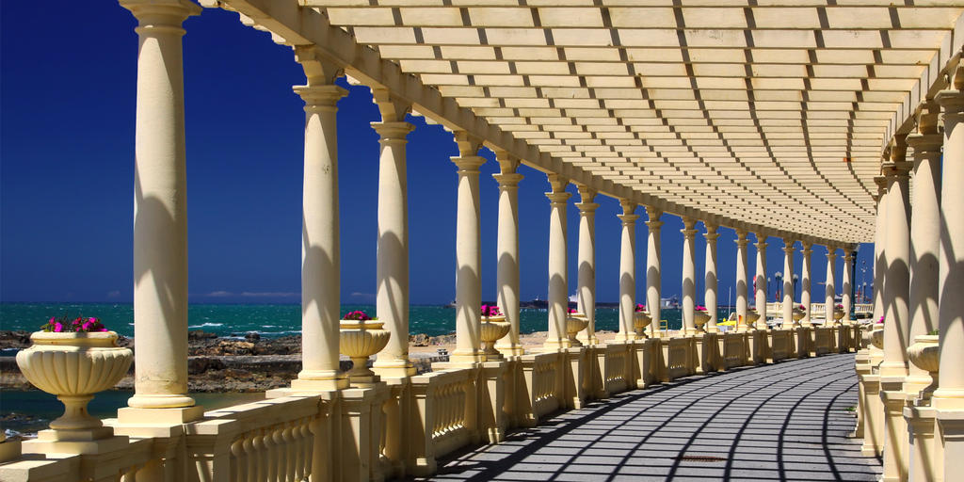
It is a fantastic place to stroll along the seafront, and to enjoy a drink on one of the beautiful terraces facing the sea.
The Oporto Streets

We can consider the streets of Porto, one of the greatest factors of authenticity, not only for its architecture, but also for its inhabitants who live there.
It is especially in the historic center, particularly in the area of ​​Sé, Ribeira and Miragaia, that you can see the daily life of the residents of Porto with their clothes to dry, dialogue between neighbours and much of the traditional trade.
These historic streets with old building lines, which intertwine and create an authentic labyrinth, along with the new cafes and art galleries, make the city of Porto at the forefront of tourism.
Some of the streets that stand out to visit, are:

Rua de Santa Catarina

The famous Rua de Santa Catarina, is a commercial street with a lot of movement all year round. It can be said that it is almost an outdoor commercial center, where some traditional shops are joined with the main European brand stores.

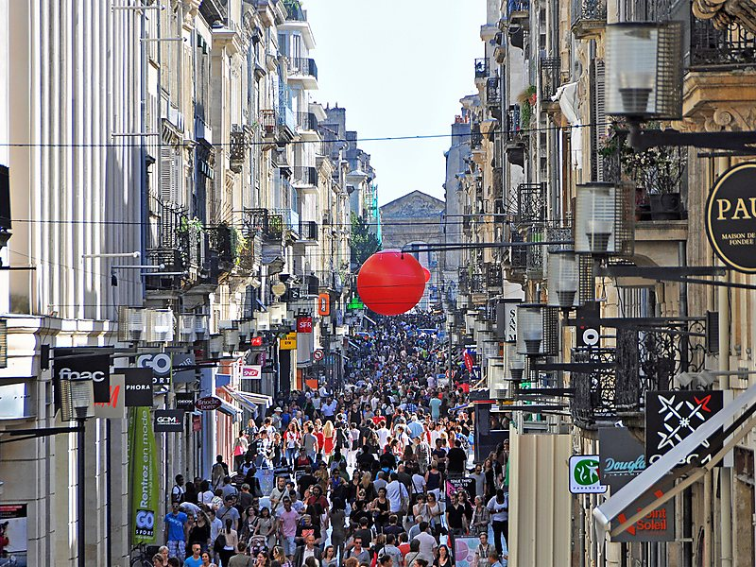

In addition to the shops, there are also cafes and restaurants, among which we highlight the emblematic Café Majestic, with its façade and its interior very appreciated by all who visit it.

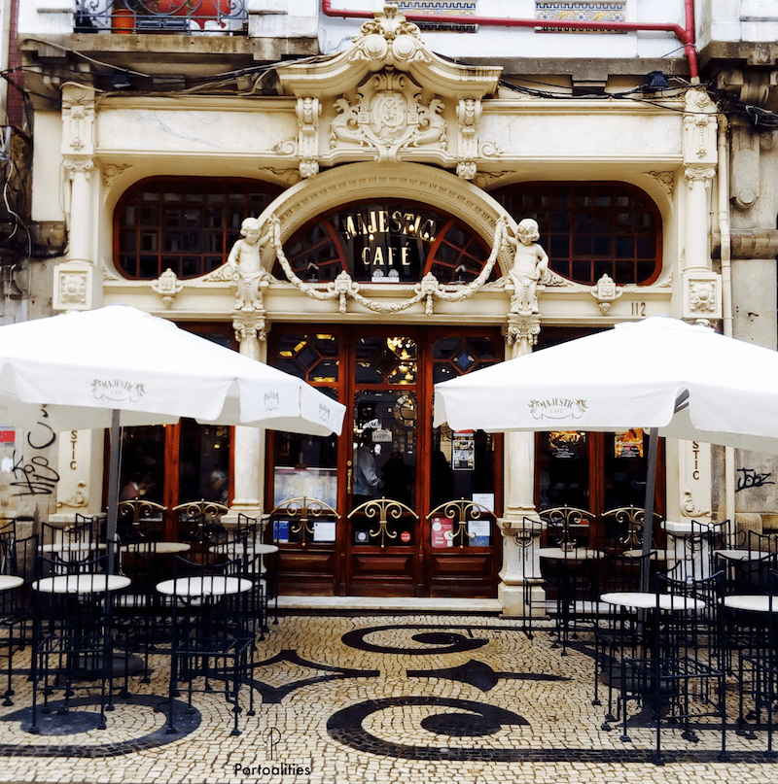

It will also be important to make a stop in the small church, “Capela das Almas”, famous for its beautiful hand painted tiles, built at the end of the century. XVIII.
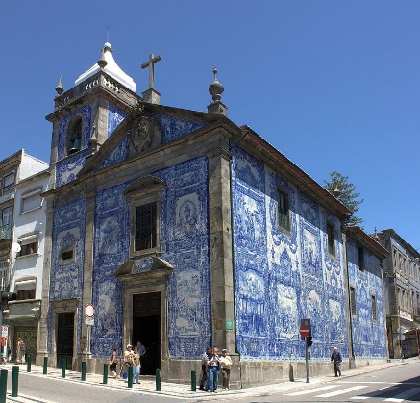

Rua de Passos Manuel
It is one of the streets that crosses with Rua de Santa Catarina. Here is located the Colosseum, where events and concerts are held. At the top of this street you will find Praça dos Poveiros, the meeting point of the best street food restaurants in the city. Here you can enjoy specialties like “Francesinha”, the typical “cachorrinhos” (hot-dogs) and other restaurants famous for their snacks.
Next to the square you can find the garden of S. Lázaro, where one of the largest urban market of the city is also held.

Rua Galerias Paris
If you are looking for the best place to go out at night, this will be the best option.
This street, as its name indicates, had several art galleries, and today almost all have been converted into cafes, bars and nightclubs. The overnight movement is quite pleasant, where the concept will be jumping from bar to bar, or even meeting with friends on the street.
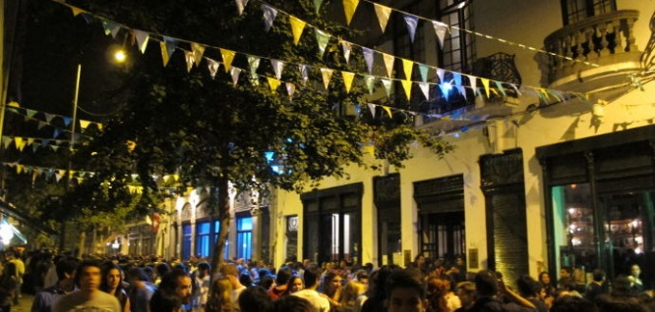

Very close to the previous street, it is possible to visit the emblematic bookstore Lello and the Clérigos Tower.
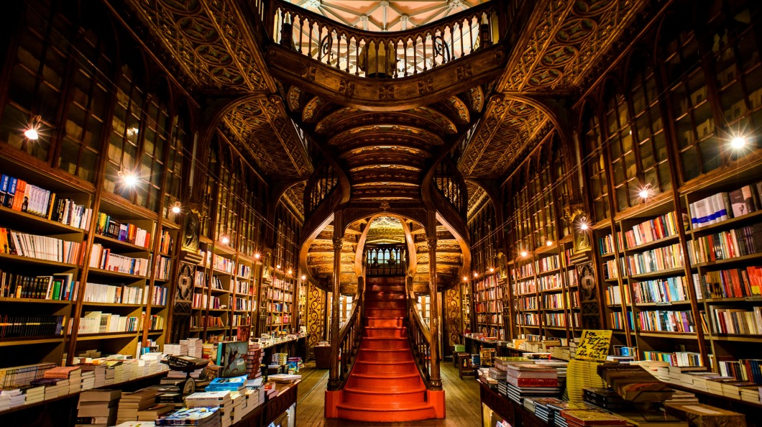

Rua das Flores
It is one of the streets that has been recently renovated, where are some of the best cafes, ice cream shops and restaurants in the city.

Rua de Cedofeita
Another of the most appealing streets of the city is Rua de Cedofeita (one of the first arteries built in the city of Porto), almost exclusively for pedestrians, made up of a Portuguese sidewalk with white and black stones, where you can visit several commercial spaces.
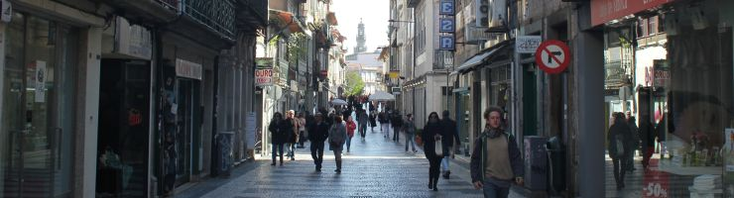
t the end of the street you will find the Plaza de Carlos Alberto, where every Saturday is a market with handmade products (Mercado Porto Belo).

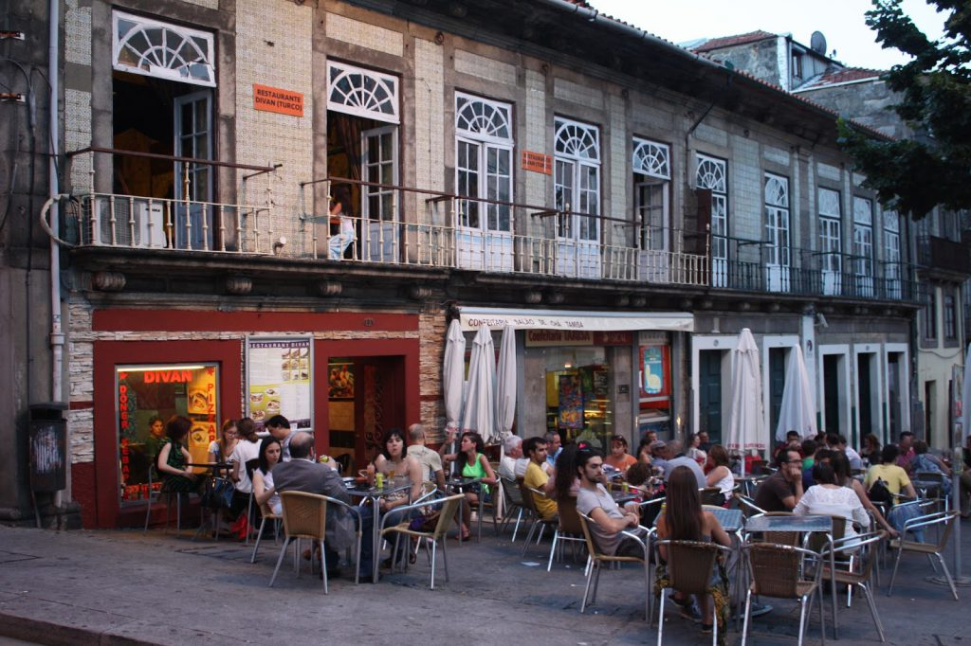
Rua da Picaria
This small street, which for some years was famous for carpentry, is currently referred to as an excellent gastronomic place of the city. You can find Portuguese snacks, sushi, Venezuelan food and some with a more traditional Portuguese menu.

Rua do Almada
Traditionally known for selling building materials and electricity, some of these businesses still remain, but others are giving rise to interesting alternative souvenir shops, galleries and restaurants.

Rua Miguel Bombarda
This is a street famous for its art galleries and art and fashion design shops. This area of the city is also called the arts district, and once a month galleries and art exhibitions are inaugurated.
