Eating in Porto

It has always been easy to eat well in Porto. The variety is huge, from affordable restaurants to the finest restaurants.
Apart from being a city with quite gastronomic fame, comparing with other European destinations one can also say that it is not expensive. The average value of one meal per person is between € 10 and € 15.
There are several gastronomic specialties.
We start with one of the most sought-after dishes: Francesinha. It is a sandwich in which its interior is composed of different types of sausages and steak. Afterwards it is covered with melted cheese and last and most important, submerged in a special sauce (made with tomato, beer and spicy). It can be served with French fries.

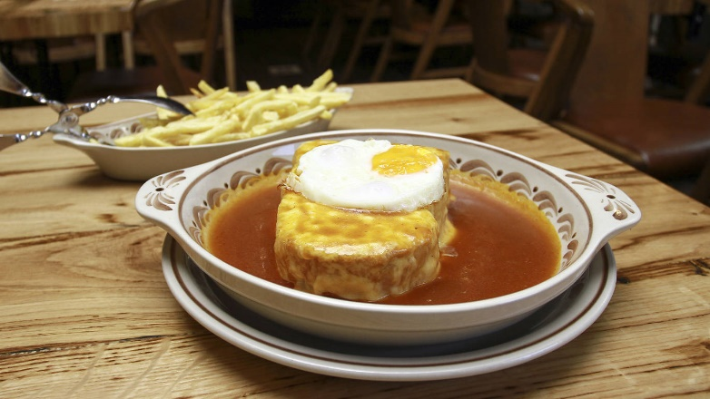
Where we recommend Francesinha:
- Lado B (Rua de Passos Manuel 190)
- Brasão (Rua de Ramalho de Ortigão 28)
- Francesinha Café (Rua da Alegria, 946)
- Santiago (Rua de Passos Manuel 226)
- Bufete Fase (Rua de Santa Catarina, 1147)
- Capa Negra (Rua do Campo Alegre, 191)

Another very emblematic dish of the city Porto, are the famous Tripas à Moda do Porto.
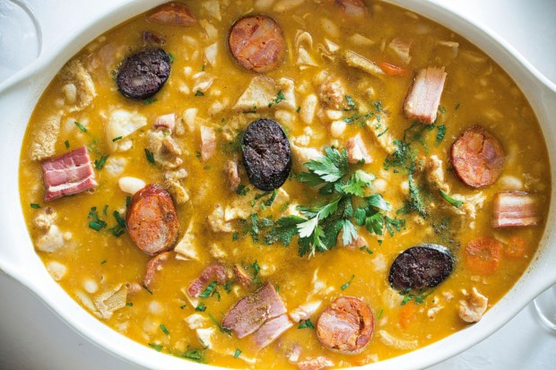
As its name implies, its basic ingredient is the guts of the cow. Historically, this is a recipe that comes from the times of the Portuguese discoveries, in the 19th century. XV.
At the time, Infante D. Henrique King asked the inhabitants of the city of Porto to provide all the meat available to the navigators who travelled with him, leaving the city with the remains, such as guts. As there was no more meat and as '' need sharpens the sugar mill '', it was so
created the recipe of Tripas à Moda do Porto. It is served with vegetables and other meats like chicken are added. It is a dish recommended to meat lovers.

Where we recommend the guts to the fashion of Porto:
-Taberna Santo António (Rua das Virtudes, 32)
- O Rápido (Rua da Madeira, 194)
-Casa Aleixo (Rua da Estação, 216)
-O Tripeiro (Rua de Passos Manuel, 195)

Besides the Francesinha, there are other tidbits that you can not fail to taste, such as:
The typical Gazela “Cachorrinhos” (Rua Entreparedes, 8)
The pork sandwiches of Casa Guedes (Praça dos Poveiros, 130)
The “bifanas” of the Conga (Rua do Bonjardim, 314)
The roasted chicken of Pedro dos Frangos (Rua do Bonjardim, 312)
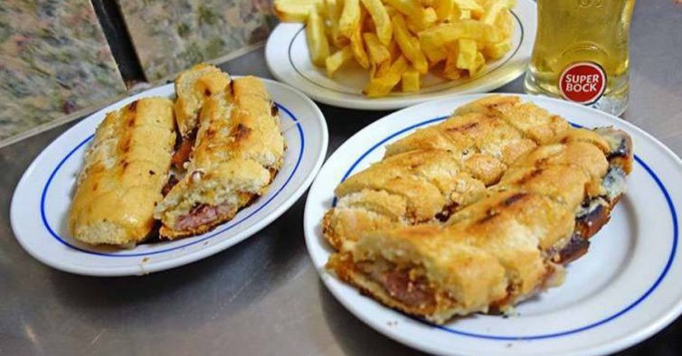

If you are a fish or shellfish lover, you will not be short of options either. Matosinhos is undoubtedly the place where you will find the greatest diversity and quality of this type of gastronomy.
Some places where you can delight yourself:
-O Gaveto (Rua Roberto Ivens, 824)
-O Valentim (Rua Heróis de França, 263)
-Tito I (Rua Heróis de França, 279)
-Armazém do Peixe (Largo Padre Joaquim de Araújo, 311 V.N.Gaia)
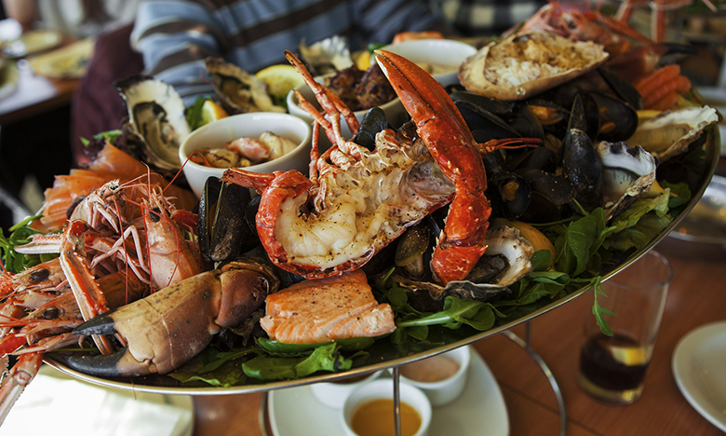

If on any of your days in Porto you would like to have a more exquisite gastronomic experience, and savor some specialties of the high gastronomic Portuense, there are several places renowned with their famous chefs.
Here are some suggestions:

-O Paparico (Rua de Costa Cabral, 2343)
-Antiqvvm (Rua de Entre-Quintas, 220)
-Cafeína (Rua do Padrão, 100)
-Terra (Rua do Padrão, 103)
-Flow (Rua da Conceição, 63)
-Muu Steakhouse (Rua do Almada, 149A)
-Enoteca 17-56 (Rua de Serpa Pinto, 44B Vila Nova Gaia)
-Pedro Lemos (Rua do padre Luís Cabral, 974)
-DOP (Largo S. Domingos, 18)

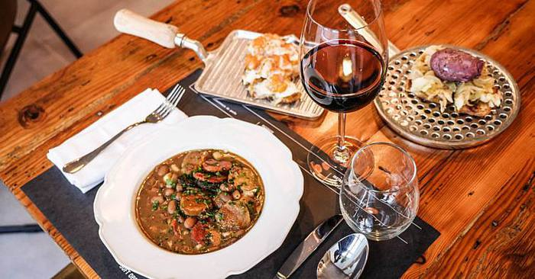

The city's sweets are also much sought after by those who stroll through Porto.
We refer to some places of election:
O “pastel de nata” da A manteigaria (Rua de Alexandre Braga, 24)
Os “jesuítas” da Confeitaria Moura (Rua de Rodrigues Sampaio, 115)
O “bolo de S. João” da Confeitaria do Bolhão (Rua Formosa, 339)
Os “éclairs” da Leitaria da Quinta do Paço (Praça Guilherme Gomes Fernandes, 47)
